**Trello – KCAL** <https://trello.com/b/gaHNplDH/kcal>

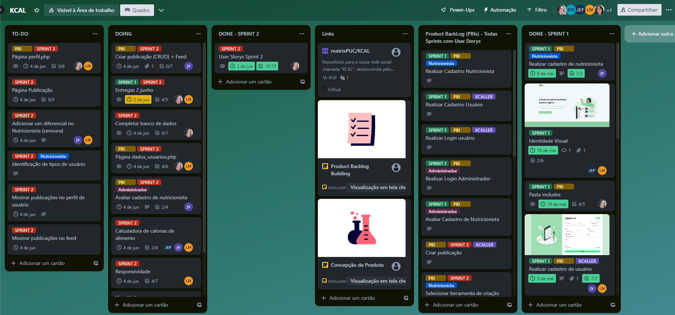Alunos: BEATRIZ KHEY ANDRADE SANTOS, BRUNO MARQUES ALVES MACIEL, JOÃO ELIAS FADEL, JOÃO VITOR WIELEWSKI, LOHINE MUSSI